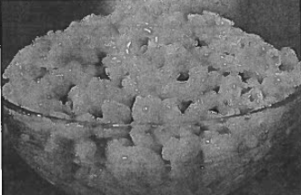
Baked Macaroni and Cheese
Ingredients: Pasta
- 1 Pint of Water
- 1½ Cups Elbow Macaroni
Directions: Pasta
- Fill pot full with water, cover, and place on high heat. Let come to boil.
- Add macaroni and cook uncovered for 10 minutes, stirring occasionally.
- Drain in a colander or strainer then rinse with cold water.

Ingredients: Cheese Sauce
- 2 Tbsp. Butter
- 2 Tbsp. Flour
- 1/8 tsp Pepper
- 1 Cup Milk
- 8 oz. Velveeta Cheese
- 2 Tbsp. Bread Crumbs
Directions: To make cheese sauce and assemble:
- Cut cheese into cubes on a cutting board.
- Measure flour and pepper into a small dish. Combine with fork.
- Measure milk.
- In a medium sauce pan, over medium heat, melt butter.
- When butter is melted, add flour mixture and stir with wire whisk.
- Gradually whisk in milk over medium heat.
- Over low heat add the cubed cheese until melted.
- Combine cheese sauce and pasta and mix well.
- Lightly grease a baking dish.
- Pour pasta in baking dish and sprinkle lightly with bread crumbs.
- Label and place in the refrigerator.
- Bake in 350˚oven for 40 minutes or until bubbly.
Equipment Needed:

