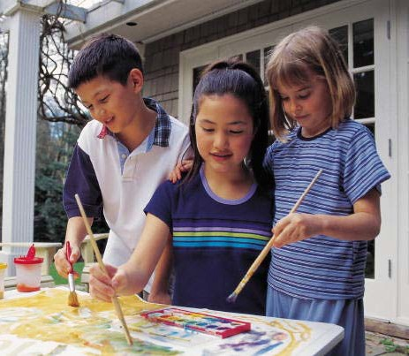

Journal
What position are you in your family in relationship to your siblings?
Describe that position.

Family Placement
Activity
Students who are:
- The oldest child go to the NE corner of room.
- The youngest child go to the SE corner.
- The middle child go to the SW corner.
- The only child go to the NW corner.
Each group is to list the advantages and disadvantages of their birth order on the butcher paper. Each group will present their findings.

Birth Order

The order in which children are born into a family influences the development of the children.
Oldest children bear the burden of the parents’ heaviest expectations and also of the parents’ inexperience in raising children.
Second or third children are generally treated in a more relaxed way by the parents.
Youngest children often have a more difficult time in making the transition to adulthood.

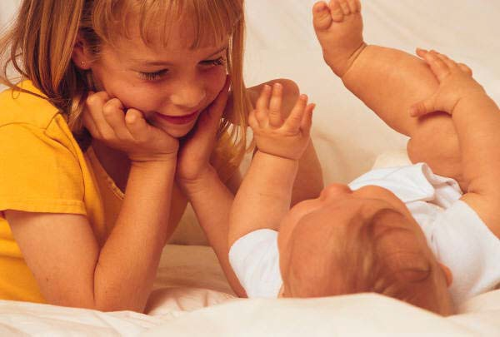
Oldest Child

Usually set up as an example to the other children.
Treated more like an adult by his/her parents. A high achiever.
Given and accepts more responsibility than the other children.
Usually college-bound. Independent.
Affectionate.

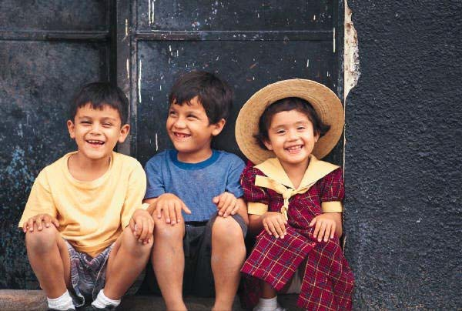
Middle Child

May work extra-hard to get recognition.
Is usually a peacemaker.
Is somewhat average in schoolwork, but is an all-around good student.
Is usually a calm, even-tempered adult.

Youngest Child
Gets a lot of attention, along with a lot of bossing.
May be spoiled.
Usually matures quickly.
May be undisciplined and irresponsible.
Is easy-going about school.
Likes to associate with someone who takes charge of situations.

Toothpaste Activity

Student draws a line on the black paper with the toothpaste for every degrading thing I say and a circle for every positive comment.
Give the paper to another students.
Have this student put the toothpaste back into the tube of toothpaste.

Once we have said something, we can never take the words back –
they have left their mark!

Sibling
Rivalry

Competition among children of the same family for their parents’ affections or for dominance.
It can occur at any age, even into adult life.
Next to the parent-child relationship, the sibling relationship is probably the strongest.

