NESTLÉ® TOLL HOUSE® original chocolate chip cookies
The chocolate chip cookie that started it all! NESTLÉ® TOLL HOUSE® original chocolate chip cookies are a true classic and the go-to cookie for all occasions!
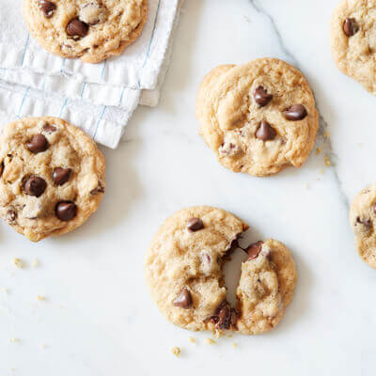
- PREP TIME
15 MINUTES
- COOKING TIME
9 MINUTES
- SKILL LEVEL
EASY
- MAKES
5
DOZEN COOKIES

IN THIS RECIPE

INGREDIENTS
- 2 1/4 cups all-purpose flour
- 1 teaspoon baking soda
- 1 teaspoon salt
- 1 cup (2 sticks) butter, softened
- 3/4 cup granulated sugar
- 3/4 cup packed brown sugar
- 1 teaspoon vanilla extract
- 2 large eggs
- 2 cups (12-ounce package) NESTLÉ® TOLL HOUSE® Semi-Sweet Chocolate Morsels
- 1 cup chopped nuts

INSTRUCTIONS
PREHEAT oven to 375° F.
COMBINE flour, baking soda and salt in small bowl. Beat butter, granulated sugar, brown sugar and vanilla extract in large mixer bowl until creamy. Add eggs, one at a time, beating well after each addition. Gradually beat in flour mixture. Stir in morsels and nuts. Drop by rounded tablespoon onto ungreased baking sheets.
BAKE for 9 to 11 minutes or until golden brown. Cool on baking sheets for 2 minutes; remove to wire racks to cool completely.
PAN COOKIE VARIATION: Preheat oven to 350° F. Grease 15 x 10-inch jelly-roll pan. Prepare dough as above. Spread into prepared pan. Bake for 20 to 25 minutes or until golden brown. Cool in pan on wire rack. Makes 4 dozen bars.
SLICE AND BAKE COOKIE VARIATION:
PREPARE dough as above. Divide in half; wrap in waxed paper. Refrigerate for 1 hour or until firm. Shape each half into 15-inch log; wrap in wax paper. Refrigerate for 30 minutes.* Preheat oven to 375° F. Cut into 1/2-inch-thick slices; place on ungreased baking sheets. Bake for 8 to 10 minutes or until golden brown. Cool on baking sheets for 2 minutes; remove to wire racks to cool completely. Makes about 5 dozen cookies.
* May be stored in refrigerator for up to 1 week or in freezer for up to 8 weeks.
FOR HIGH ALTITUDE BAKING (5,200 feet): Increase flour to 2 1/2 cups. Add 2 teaspoons water with flour and reduce both granulated sugar and brown sugar to 2/3 cup each. Bake drop cookies for 8 to 10 minutes and pan cookie for 17 to 19 minutes.

