Name: _________________________________
Parts of the sewing machine
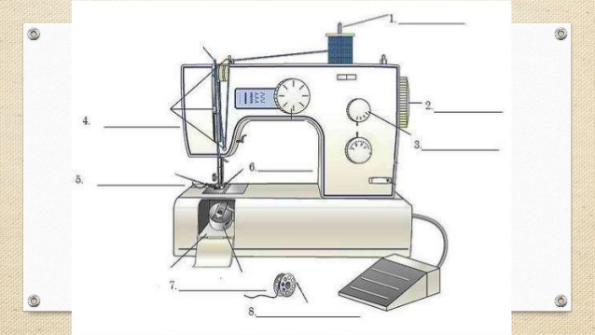

What is their purpose?
1.___________________________________________________________________________________
2.___________________________________________________________________________________
3.___________________________________________________________________________________
4.___________________________________________________________________________________
5.___________________________________________________________________________________
6.___________________________________________________________________________________
7.___________________________________________________________________________________
8.___________________________________________________________________________________

