Answer Key
Name: _________________________________
Parts of the sewing machine
Fill in the names below
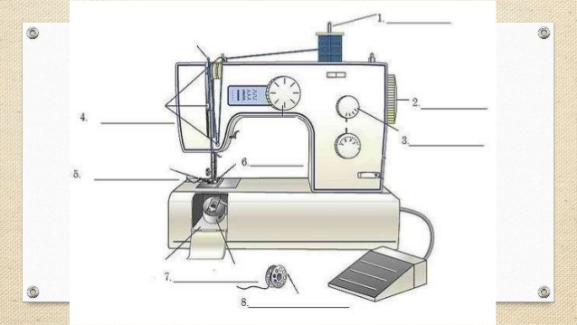

What is their purpose?
1. Bobbin winder spindle- Holds bobbin while it winds.
2. Hand wheel- Controls movement of take up lever & needle.
3. Stitch width control- Sets the width of zig zag stitch.
4. Thread guide- Holds the thread in place on the sewing machine.
5. Dog feed- Moves fabric along as you sew.
6. Presser foot- Holds fabric in place as you sew.
7. Bobbin case- Holds bobbin, allows bobbin to turn & form stitch.
8. Bobbin- Holds thread inside the machine.

