Quick Tomato Sauce 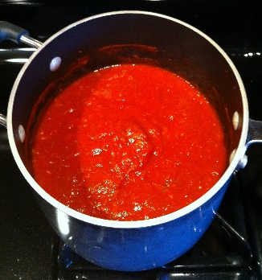
This Photo by Unknown Author is licensed under CC BY-NC-ND

Ingredients
1 (28-ounce) can chopped tomatoes
2 cloves garlic, pressed
1/4 cup extra-virgin olive oil
1 teaspoon sugar
1/4 teaspoon salt
2 teaspoons dried oregano

Directions

- In a medium bowl, combine all ingredients and let sit for about 20 minutes to allow flavors to meld.
- Cook's Note: Sauce can be made ahead of time and kept covered in the refrigerator for up to 3 days or frozen for up to 3 months.

