Mrs. Belgiorno

Family and Consumer Sciences

Name:

Date:

Show Me the TV Family: Paper Plate Project
After teaching several lessons on family structures, family functions, and family life cycle stages, I use this lesson/project as a way for students to review and apply information learned as well as a way for me to assess their learning. Students select a television family and create a TV Paper Plate Project using their knowledge of family to complete it. Students use mobile labs to research any unknown information about their TV family such as names of all family members or jobs TV parents held, etc.
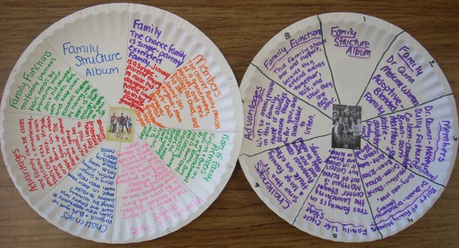Time Frame: 1.5-2 Periods (43 minutes)
Class Size: 16
Objectives
- To review and apply family structure, family functions, and family life cycle stages information learned about the family through an interactive project.
Set
- Brainstorm “TV families” as a class. Here are some to get you started:
  - Prichetts
  - Cleavers
  - Andersons
  - Full House
  - Jetsons
  - Simpsons
  - Cosby
  - Cunningham
  - Brady
  - Griffin
Materials
- Paper Plate–ones you can fold and write directly on.
- Colored markers or pencils
- Scissors
- Computer Access
Background for Teachers
- Knowledge of family structures, family functions, and family life cycle stages.
Instructional Procedures
- Students select a television family (older or current)to use to complete their TV paper plate project. Students may use their notes as well as mobile labs to gather information about their TV family to complete the project.
- Divide paper plate into 8 sections
- Glue a picture of “the family” in the center
  - Section 1: Title & Your Name
  - Section 2: TV Family Name & family structure type
  - Section 3: TV Family Member’s Names & identities
  - Section 4: Basic Roles & tasks each member is responsible for
  - Section 5: Stage of family life cycle
  - Section 6: Identify family challenges
  - Section 7: Advantages & positive characteristics of this family
  - Section 8: Family functions
Activities
- Create a TV Paper Plate Project that shows me your knowledge of family information learned within the unit.
Closure
- After projects have been completed and graded I hang them around my room. Students from other classes enjoy viewing and reading about older and current TV families.
Evaluation
- Project grading rubric (second page of attachment)

